**SCM SAMPLE ASSIGNMENT**

STEP 1: Repository Setup and Initial Commit

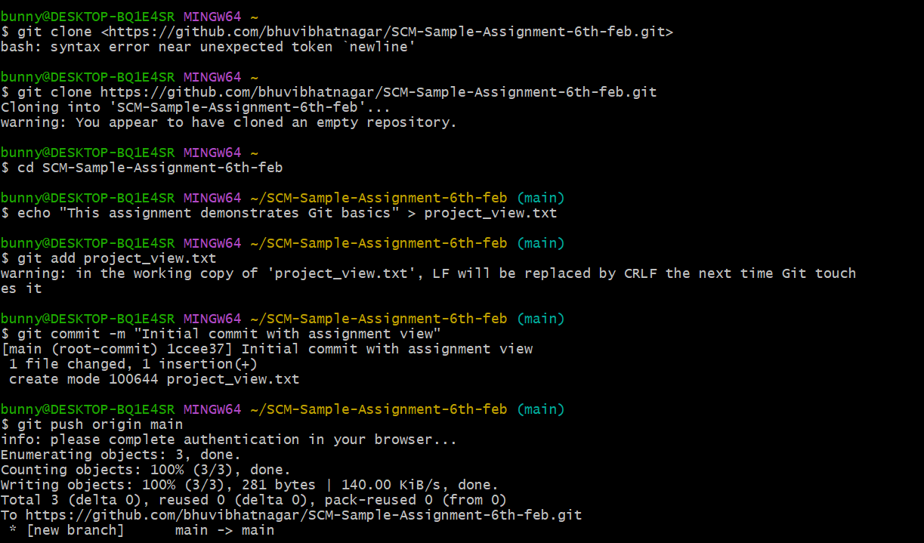

STEP 2:Branch Creation and Updates

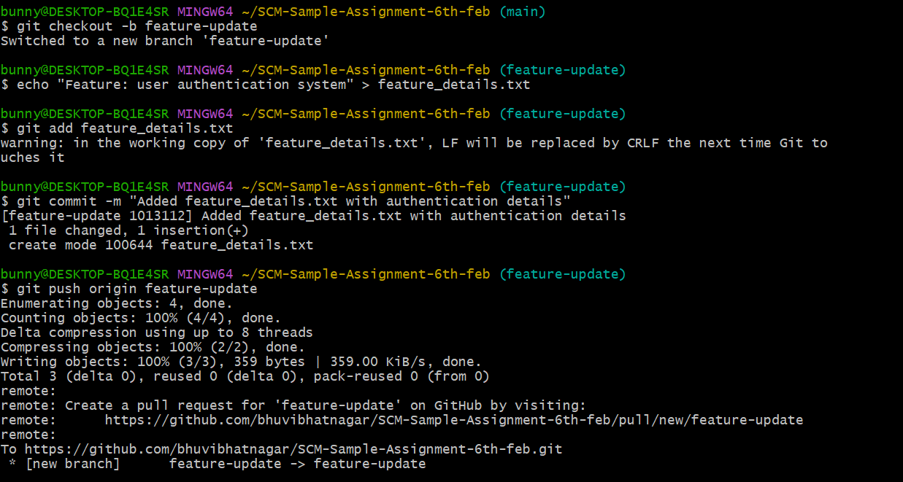

STEP 3:Merge and Conflict Resolution

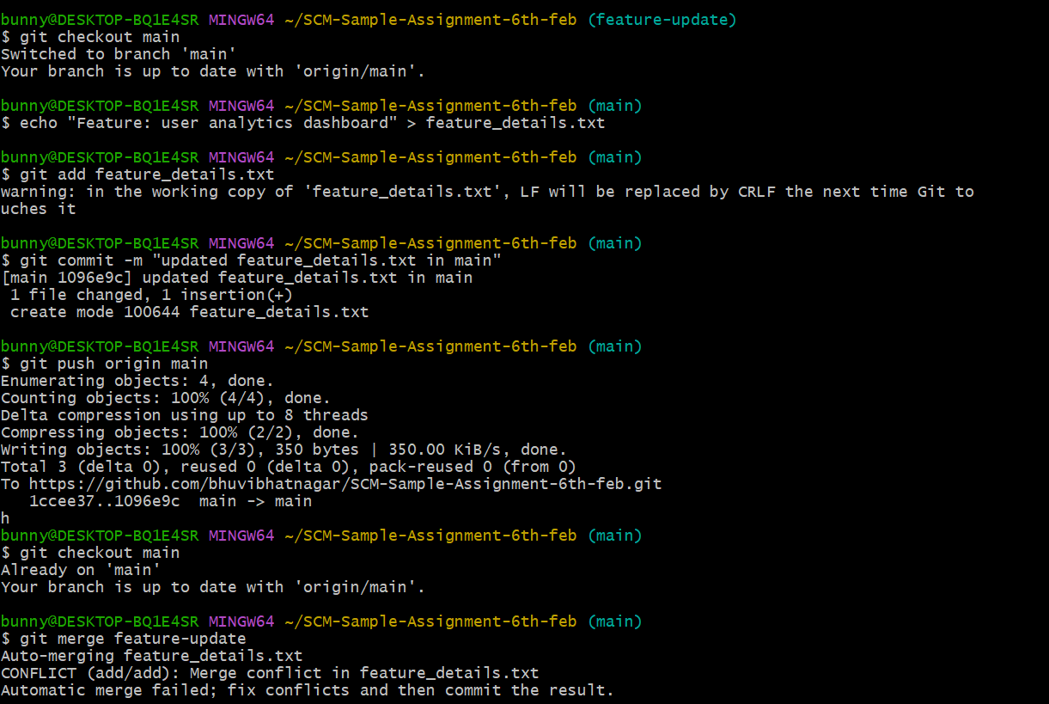

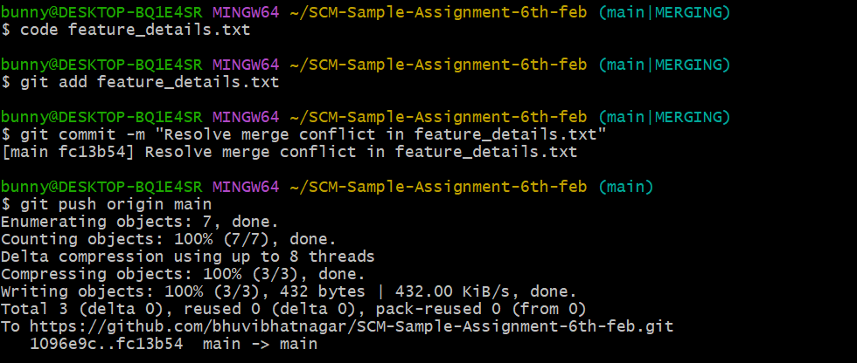

STEP 4:Repository Audit

